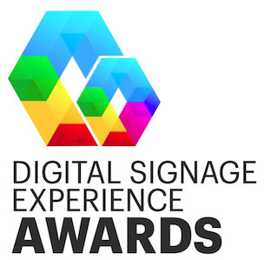
2023 Digital Signage Experience Awards (DIZZIES)
Nomination Worksheet

This worksheet is intended to help you gather all of the information you will need to submit your nomination.

For Company Awards, submit your information through our official online nomination form.
Each entry costs $195. Eligible projects must have been active between January 2022 to the present.

For Individual Awards, use our submission form here. There is no cost to submit to these awards.

Company Awards Worksheet

You do not have to finish the application in one sitting. You may save your work and log back in at a later time to complete your incomplete submission(s).

As a reminder, each entry is for a single project/campaign. If you intend to have multiple projects/campaigns reviewed, you will need to submit an application for each.

Thanks and good luck!

Project/Campaign Name (15 words maximum):

Project Overview / Background (500 words maximum):

Project Problems and Challenges (500 words maximum):

Project Solutions (500 words maximum):

Project Outcome and Results (500 words maximum):

Additional Assets to Support Your Nomination

- Project Photo
- Optional Video: We strongly encourage a video submission to support your nomination. Please provide the URL for the video, and password if required.
- Company Logo (required)
- Optional Client Company Logo

----------------------

Individual Awards Worksheet

Please submit a brief background on your nominee and why they are deserving of this award.

